BAD GRAPH OR TABLE REDESIGN PROJECT USING

Statistical Analysis Using R

Original Graph

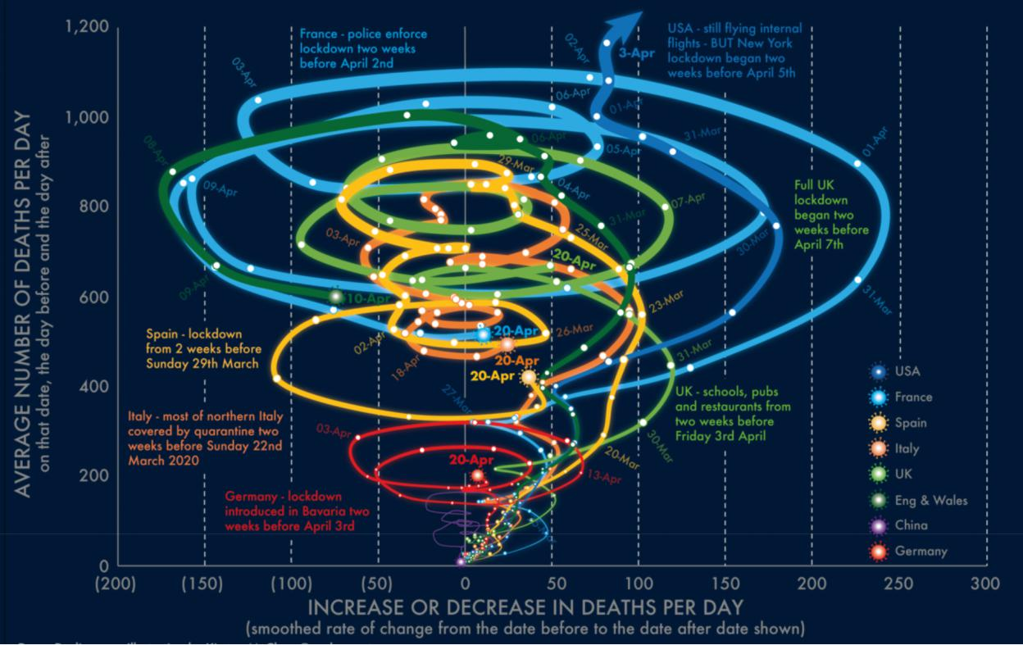

Figure 1: Bad Graph

The graph is about the Mortality in seven countries (USA, France, Spain, Italy, UK, England and Wales, China, Germany) attributed to COVID-19 (March 20 to April 20, 2020).

It is in the shape of a Tornado, where the X-coordinate is about the increase or decrease in deaths per day which has a range of (200, 0, 300) and the Y-coordinate has the number of deaths per day with range (0, 1200). Each color represents the fall and rise of deaths for each country along with dates at each fall or rise and a short note about each country’s lockdown situation which is clumsy having all these points mentioned at the same place.

Source: https://i.stack.imgur.com/YROdX.jpg

Why is it a bad graph?

Too much data for a graph: The graph is mainly plotted for change in deaths per day against the average number of deaths per day, for different countries. Along with this data, different dates are also displayed on the graph, as well as notable events. The graph has too much information, which makes it difficult to understand and fails to portray the motive behind the graph.

Separate lines for the UK and England & Wales: The graph had different lines for the UK and England and Wales, which are part of the UK. This is strange. It would be better to either have a single line for the UK or have separate lines for different countries in the UK.

The wrong choice of axes: Both the axes are representing different things, which do not correlate with each other. The Y-axis represents the number of average deaths, whereas the X-axis represents the change in the number of average deaths. We can compute the change in the number of average deaths from the actual number itself. Graphically presenting them with each other does not add up any value to the viewer.

Unusual visualization result: The wrong choice of axes has turned the line chart into an unusually shaped tornado visualization. The cases increasing overtime gave height to these visualization lines whereas the x-axis is divided into two parts for the increase and decrease resulting in the line going back and forth. Visualization is more effective if the viewer identifies the pattern of it.

Randomly positioned events: The graph lines have key events shown on each line with the date. The graph is changing in both directions, placing the events in a random way and no way to compare the events for the same time in different countries.

Data set

The bad visualization did not come with the source of the data. Hence, we had to extract the data ourselves to work on the visualization. So, we extracted the dataset from Johns Hopkins University’s website that provided us with the worldwide COVID 19 data. From that huge dataset which contained data from several countries across the world for more than a year, we pulled out only what is needed for the visualization, which has 15 columns and 62 rows. It has several columns with the information of numerical data i.e., the death count of each country (USA, France, UK, Spain, Italy, China, Germany) daily i.e., Date from 1st of March to the 30th of April 2020 which we filtered accordingly. Then, adjusted data to the specified countries (excluded England and Wales as it comes under the UK) from the graph because the original dataset contained data for all countries. We pre-processed the extracted data for the missing values and then for the difference in the deaths from previous days, we created more columns for each country, which would contain the difference.

Redesign Idea

Using the libraries tidyverse, plotly, RColorBrewer, ggplot2, grid, gridExtra in R, we have cleaned the data, modified the data, and plotted multiple graphs, which are better than the original one.

Here, the two coordinates are badly chosen. If you know the deaths on April 19 and April 20, then the change is clear. Then they have graphed time, well there is not much explanation with time except some dots on ribbon like curves, but when looked closely to figure them out and there's no easy way to compare different countries at different times.

So, for x- coordinate, we could choose calendar date or date since first identified case or maybe some other time-based measure.

Then we can make the y-coordinate for deaths per day per capita unless the purpose of the graph is very particular.

Including both England and Wales, the UK is strange. It could have been just the UK, or else England, Scotland, Northern Ireland, and Wales separately (we'd go with the former).

Then we can use dots for "important events" that are included in the current version but in a way that won’t make much difference, since time isn't represented properly.

Redesign Implementation

We decided to split the graph into multiple sub graphs. Breaking down the complex graph into simple graphs could help the user understand what the visualization is trying to explain in an easier way. Our first graph has what the y axis is trying to show in the bad visualization. The second graph has what the x axis is trying to show in the bad visualization. Then we decided to generate another visualization which would further break down the second graph we generated to make the results clear and precise.

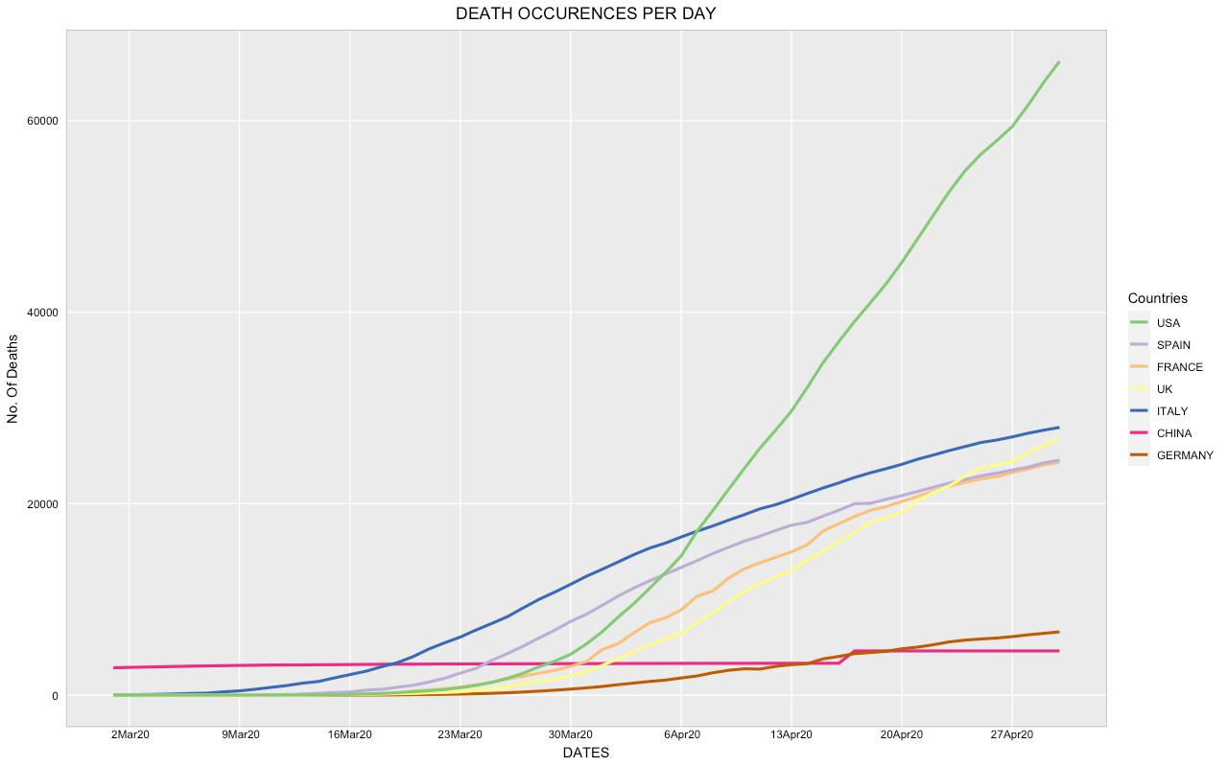

Figure 2: Number of deaths during March 1, 2020 – April 30, 2020

This multi-line graph includes just the death rates of the seven specific countries from the bad graph. As death rates increased continuously for the given time, almost all the lines in the graph are in a rising pattern.

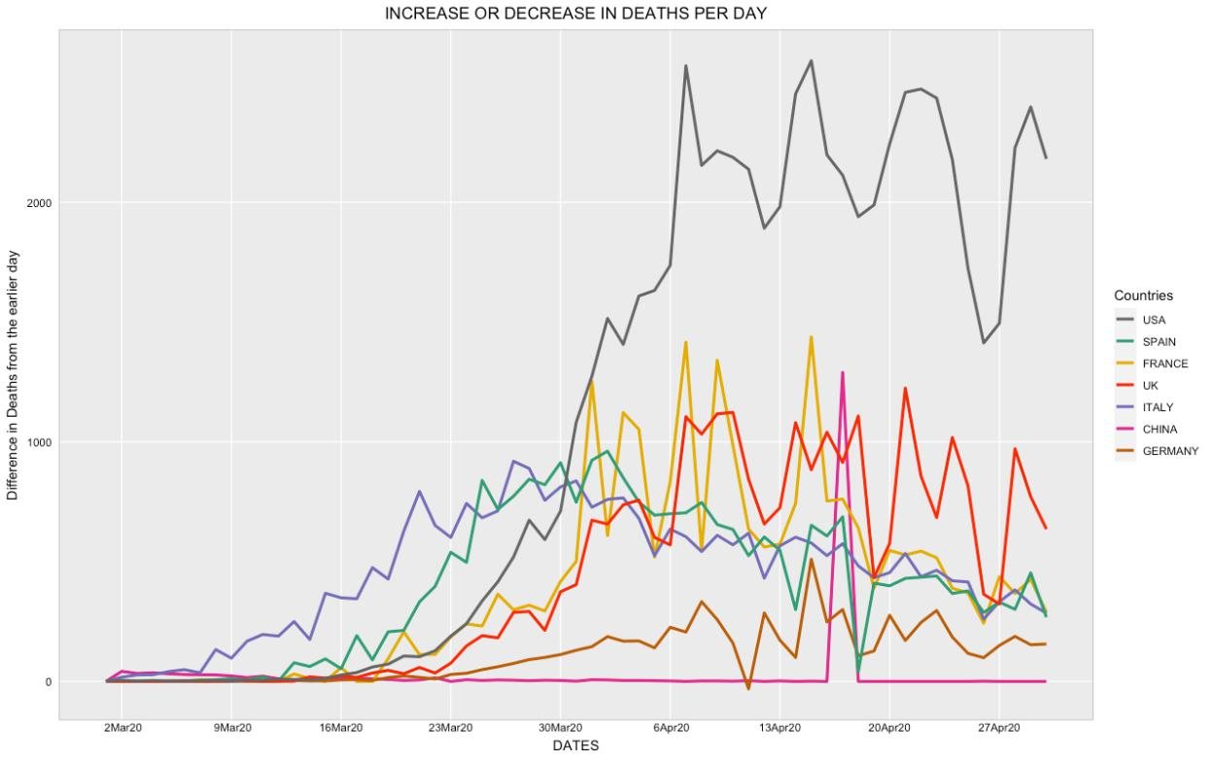

Figure 3: Difference in deaths during March 1, 2020 – April 30, 2020

(For all countries)

This multi-line graph consists of the difference in deaths from the earlier day for the given time of March 1 to April 30. We could see the seven different countries being used in the visualization. Instead of directing the drops to the left side of the x axis like in the bad visualization and directing the highs to the right side of the x axis, just normally visualizing the graph like the above conveys the message clearly to a normal user. Though this visualization is better than the bad visualization, it is still a bit clumsy due to the overlap of many different lines. Hence, the third visualization is generated to break it down further.

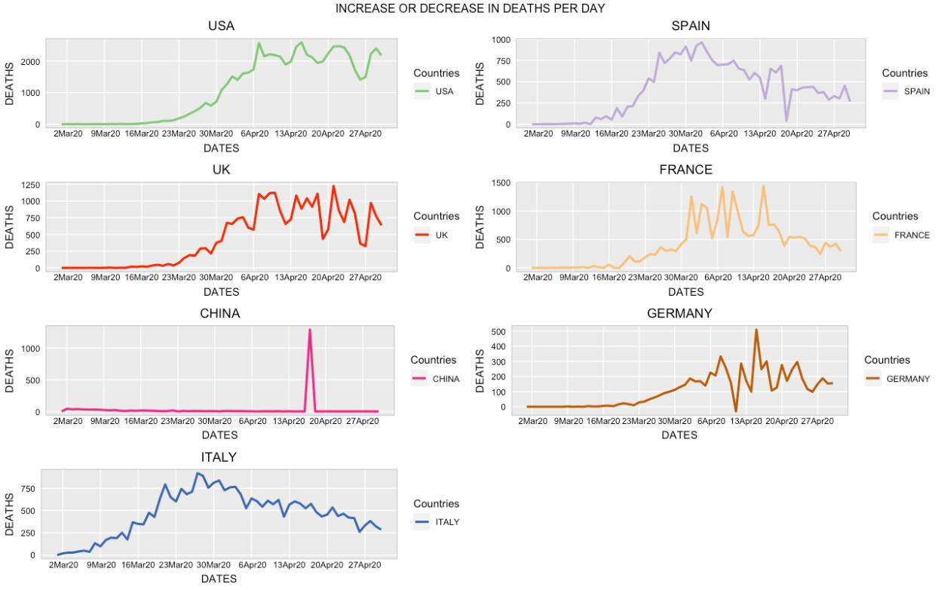

Figure 4: Difference in deaths during March 1, 2020 – April 30, 2020

(For individual country)

This visualization consists of multiple line plots, each of them individual for each country. This is a simple breakdown of the above second visualization. From all the visualizations, we could see that the USA is the most affected country amongst the others.

Challenges

Initially, we kept much effort looking for a bad graph with the right data. As Covid-19 is still emerging, it has been difficult to find credible data sources as each source provided different information which was not sufficient for proceeding further. Once we found the required data sources, Understanding the bad graph, pre-processing, and cleaning of the dataset has been the next milestone to modify according to the graphs for redesign.

Finally, by passing all these steps and applying the concepts learnt in class we hope we learned and worked as a true challenge.

Future Work

Important event text is not making sense (Then you could use dots for "important events" that are included in the current version but in a way that makes them almost useless, since time isn't represented properly.)

References

Danny Dorling Halford Mackinder Professor of Geography. (2021, October 14). Three graphs that show a global slowdown in covid-19 deaths. Retrieved October 18, 2021, from https://theconversation.com/three-graphs-that-show-a-global-slowdown-in-covid-19-deaths-135756

How to use our data. (n.d.). Retrieved October 18, 2021, from https://coronavirus.jhu.edu/about/how-to-use-our-data

(n.d.). Retrieved October 18, 2021, from https://rstudio-pubs-static.s3.amazonaws.com/170893_9e4e88b0dedc4adfa3bd5a87eb64a9ba.html

